Launch the Summary Report Tool by open SummaryReportTool.exe or from MOVES main GUI (future)

The application will connect MariaDB on local computer using the MOVES default credential, username: moves and password: moves

If the default credential failed to connect, there will be a prompt pop out to let user edit and save/submit the customized credential. Next, the application will retry MariaDB connect with the user updated username and password.

After successful connect to MariaDB, the main panel will show.

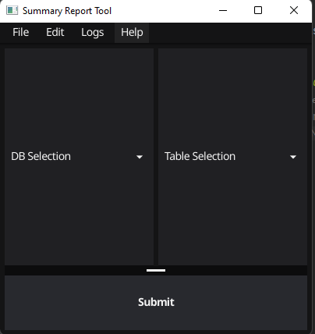

Figure 1.0 Main Panel

To explore MOVES output database

1. Click the DB Selection dropdown box and select desired MOVES output database
2. Click the Table Selection dropdown box and select desired table
   1. The application only support viewing the following 8 tables
      1. "movesactivityoutput",
      2. "movesoutput",
      3. "rateperdistance",
      4. "rateperhour",
      5. "rateperprofile",
      6. "rateperstart",
      7. "ratepervehicle",
      8. "startspervehicle"
3. Click Submit button

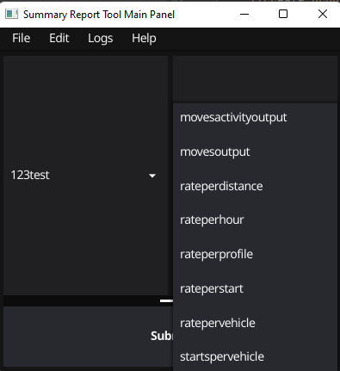

Figure 1.1 Table Selection

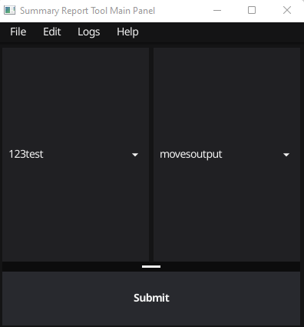

Figure 1.2 Main Panel with dropdown boxes selected

The Data View Table will display after scanning data from MariaDB, the speed is depending on the size of the output table that user selected.

By default, all ID related columns are displaying numeric ID number. Please refer to MOVES cheat sheet: [OnRoad Cheat Sheet](https://github.com/USEPA/EPA_MOVES_Model/blob/master/docs/MOVES3CheatsheetOnroad.pdf) , [NonRoad Cheat Sheet](https://github.com/USEPA/EPA_MOVES_Model/blob/master/docs/MOVES3CheatsheetNonroad.pdf)

Decoded ID will be displayed after clicking update button 

There are 3 panels in the Data Viewing Window.

1. Top: Tool bar panel, with query and unit message
2. Left: Filter panel
3. Right: Data table
   1. Data table has both vertical and horizontal scroll bars

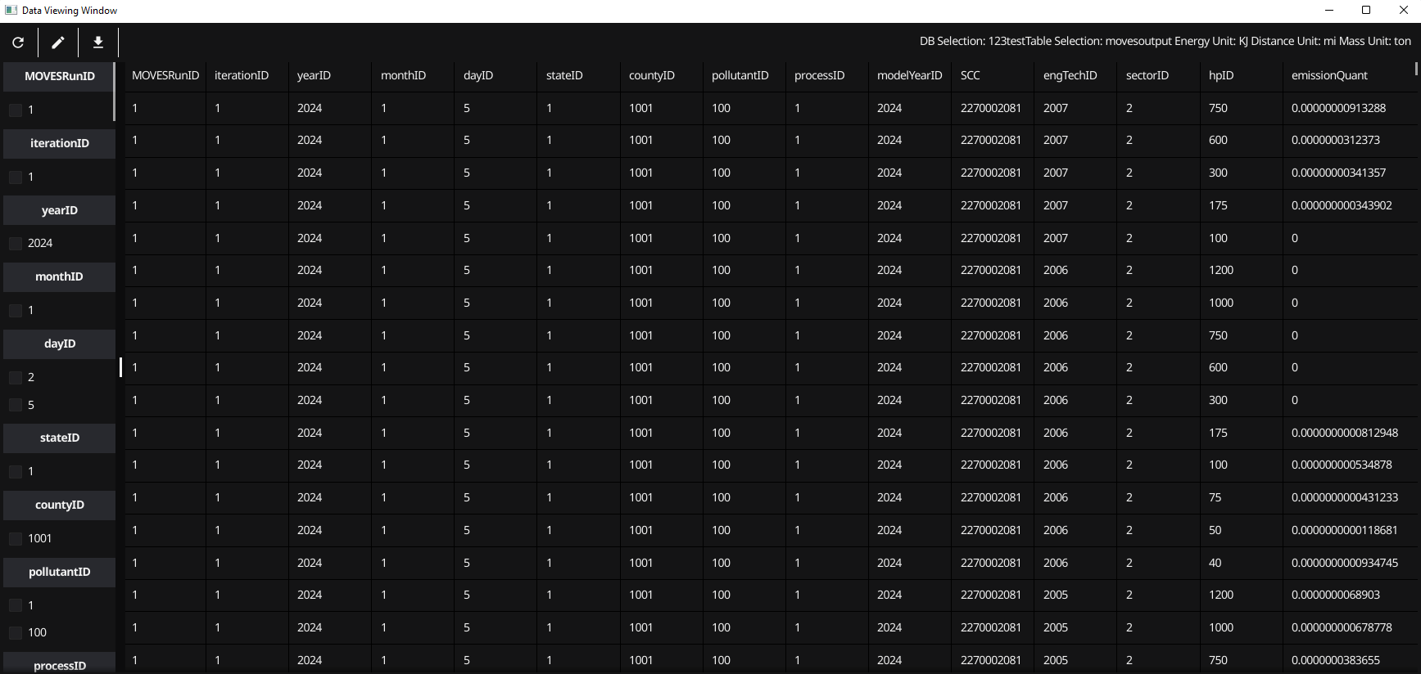

Figure 2 Data Viewing Window with numeric ID columns

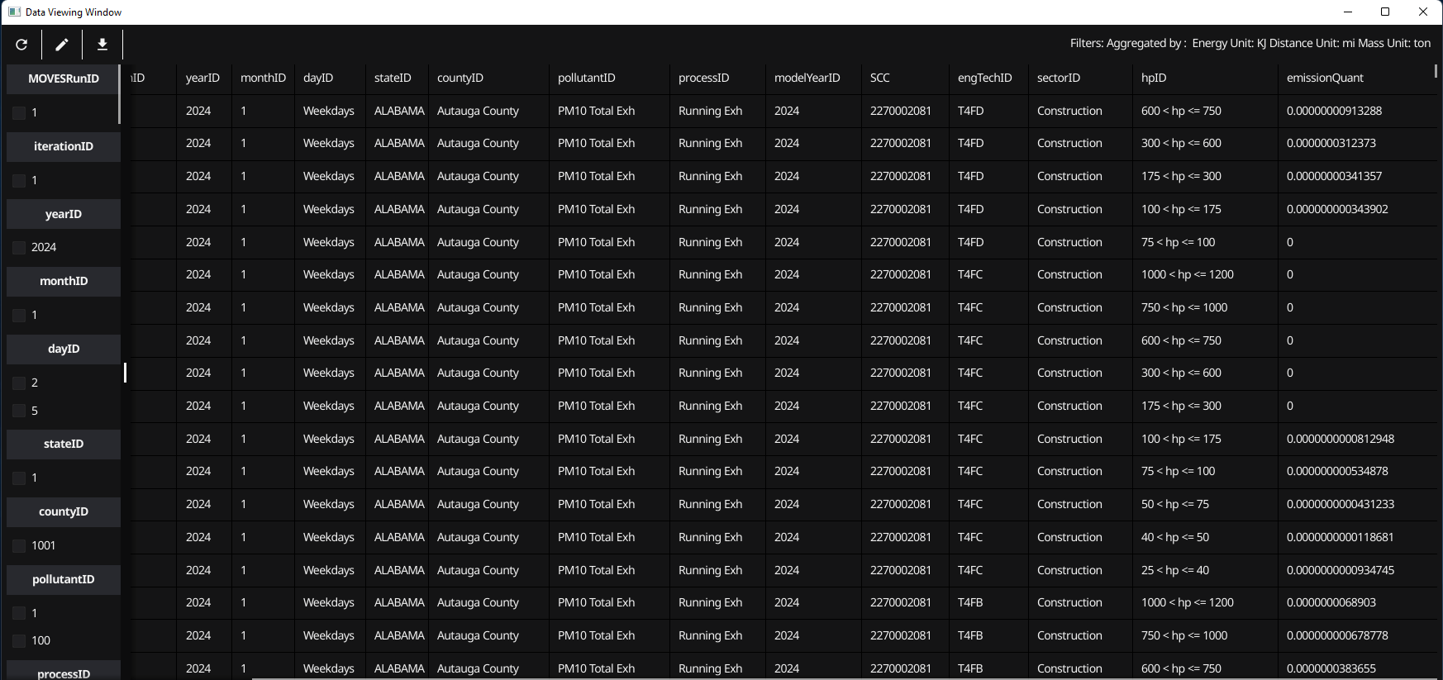

Figure 2.1 Data Viewing Window with decoded ID columns

**Toolbar**



Figure 2.2 Toolbar

Tool bar has 3 buttons:



Figure 3 Update button

Update: Update the data table base on filter and aggregation checkboxes status.



Figure 4 Plot button

Plot: Open Plot Configuration Window (only works for activity and movesoutput tables), cover it in next chapter



Figure 5 Download button

Download CSV: download data from data table to a .csv file



Figure 6 Message with filter

Message: the message label on the right corner will display the unit selection from its MOVES run. MOVES unit can be change in the MOVES GUI or in the MOVES runspec. The message will also display what columns are the filters and/or which column is aggregated/grouped.

**Filter Panel**

1. Filter panel has two sections.
   1. Filter section
      1. Group of checkboxes with numeric ID
   2. Aggregation section
      1. Group of checkboxes with column names, for example: yearID, processID, and pollutantID
2. Filter panel has vertical scroll bar
3. Filter panel will only display non-empty columns as checkboxes
   1. For example, if user find there is no filter checkbox for model year, it is because the model year column values are null. A null value column will not be displayed in both data table and filter panel.
4. Check all options in a checkbox group is equal to check nothing.
   1. For example, result A is equal result B
      1. A checked dayID 2(weekend), and 5(weekday)
      2. B checked nothing in the dayID group

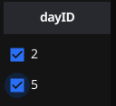

Figure 7 check all box

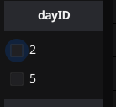

Figure 8 check no box

Filter example:



Figure 9 Message with aggregation

The message above is the result by checking dayID 2(weekend) checkbox. The filter will ignore the result of dayID 5 (weekday) and only display data rows for dayID 2(weekend)

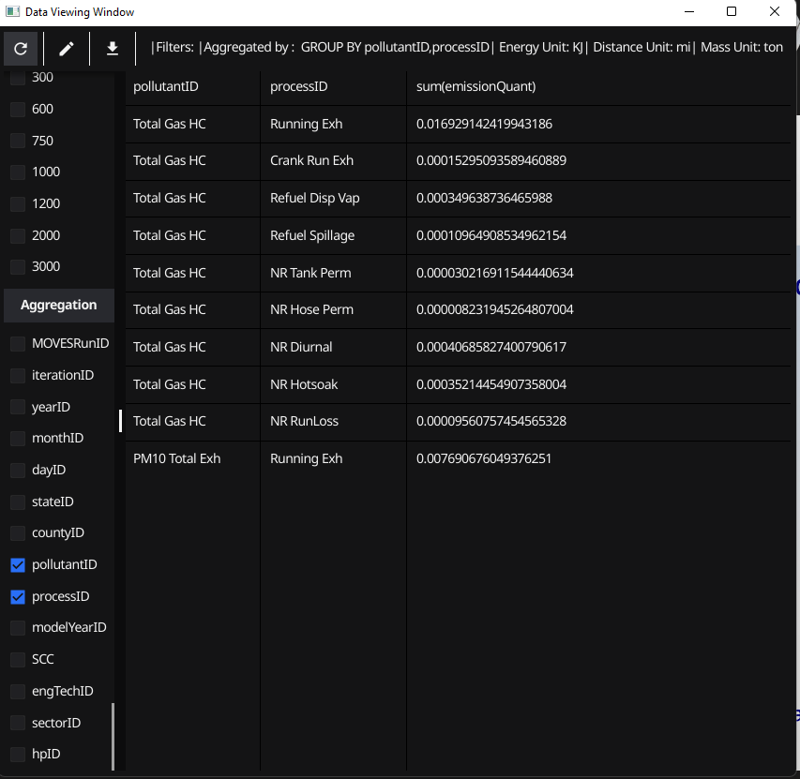

Aggregation example:

The above screenshot is a demonstration for aggregation. With pollutantID and processID checked. The data table will sum all emissionQuant that associated with same pollutantID and processID combination.

Aggregation also can work together with the filters.

**Data Table Panel**

Data table Panel only contains not null columns.